Word of Life: January 2024
Recommended dates are provided, but you are welcome to use these materials at any time!
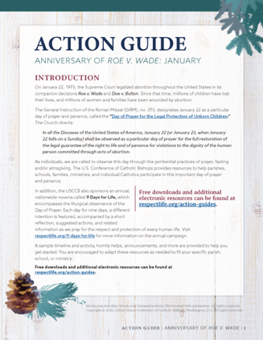
Featured this Month…
- Parish Action Guide: Anniversary of Roe v. Wade
Beginning on January 22, 1973 with Roe v. Wade, and during the nearly 50-year period following the Supreme Court decision, nearly 64 million children have been killed—and untold numbers of women and men suffer in the aftermath. Even with the overturning of Roe v. Wade in June 2022, many states continue not to recognize children in their mothers’ wombs as persons warranting protection, and federal laws fail to protect the lives of unborn children. The January Action Guide is available to help parishes, schools, and ministries highlight the sacredness of human life and pray for the protection of unborn children.
- Day of Prayer and Penance
(January 22, 2024)
January 22 is designated as a particular day of prayer and penance for Catholics in the United States, called the “Day of Prayer for the Legal Protection of Unborn Children.” The General Instruction of the Roman Missal (GIRM), no. 373, directs:
In all the Dioceses of the United States of America, January 22 (or January 23, when January 22 falls on a Sunday) shall be observed as a particular day of prayer for the full restoration of the legal guarantee of the right to life and of penance for violations to the dignity of the human person committed through acts of abortion.
Choices of Readings for Mass and other resources are available online in the January Action Guide.
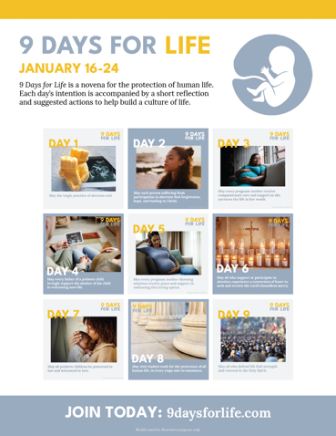
- 9 Days for Life
(January 16 – 24, 2024)
9 Days for Life is a novena for the protection of human life. Each day’s intention is accompanied by a short reflection and suggested actions to help build a culture of life. Participants can receive the novena by subscribing to daily emails or text messages. (A printable version is also available online.)
Leaders’ resources are available for download, including flyers, graphics, sample announcements, and the novena. Download or sign up for the novena at www.9daysforlife.com.

Word of Life – January 2024
Intercessions for Life
January 1st  May friends and families of women  with difficult pregnancies  provide loving, life-affirming support  for both mother and child;  We pray to the Lord: | Solemnity of Mary, the Holy Mother of God
January 7th  On this Feast of the Epiphany,  may we be given the grace  to always see in others  the face of Christ our Savior;  We pray to the Lord: | The Epiphany of the Lord
January 14th  For all Christians:  May we live out our baptismal call  to proclaim the Gospel of God’s love  and the dignity of every human life;  We pray to the Lord: | Second Sunday in Ordinary Time
January 21st  For public servants and elected officials:  May God grant them the humility, wisdom,  and courage to defend all human life;  We pray to the Lord: | Third Sunday in Ordinary Time
January 22nd  For the legal protection of unborn children  and for loving support for their mothers  before and after their births;  We pray to the Lord: | Day of Prayer for the Legal Protection of Unborn Children
January 28th  For those suffering after abortion:  May they know that the Lord desires to bring healing,  and turn to Him for His mercy and peace;  We pray to the Lord: | Fourth Sunday in Ordinary Time

Word of Life – January 2024

Bulletin Quotes
January 1st  “O Blessed Mother, you received the good news of the incarnation of Christ, your Son, with faith and trust. Grant your protection to all pregnant mothers facing difficulties. Guide us as we strive to make our parish communities places of welcome and assistance for mothers in need. Help us become instruments of God’s love and compassion.”  USCCB Secretariat of Pro-Life Activities  “A Prayer for Pregnant Mothers” | 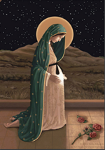  Order | Download  Online
January 7th  “Through the Incarnation and birth of Christ, God reveals to us the dignity of all human life. Human life, as a gift of God, is sacred and inviolable. The Son of God has united himself with every human being and desires for us to share eternal life with him… Each of us is made in the image and likeness of God, and we reflect his glory in the world.”  USCCB Secretariat of Pro-Life Activities  “The Gospel of Life: A Brief Summary” | Download | Read Online  Online
January 14th  “When we encounter Christ, experience his love, and deepen our relationship with him, we become more aware of our own worth and that of others. His love for each person is cause for great joy, and growing understanding of this priceless treasure motivates us to share his love with others. Our lives are often changed by the witness of others; so too, others’ lives may be changed by our witness and authentic friendship with them.”  USCCB Secretariat of Pro-Life Activities  “How to Build a Culture of Life” (respectlife.org/culture-of-life) | 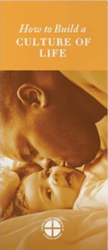  Order | Download
January 21st  “There is such a wide spectrum of issues involving the protection of human life and the promotion of human dignity. Good people frequently disagree on which problems to address, which policies to adopt and how best to apply them. But for citizens and elected officials alike, the basic principle is simple: We must begin with a commitment never to intentionally kill, or collude in the killing, of any innocent human life, no matter how broken, unformed, disabled or desperate that life may seem. In other words, the choice of certain ways of acting is always and radically incompatible with the love of God and the dignity of the human person created in His image.”  United States Conference of Catholic Bishops  “Living the Gospel of Life,” © 1998 USCCB | 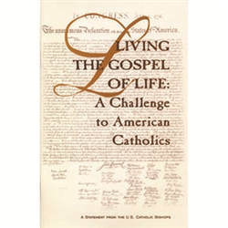  Read Online
January 28th  Many people are unaware that someone they know personally is silently suffering from participation in abortion. If a friend confided in you tomorrow that she had an abortion, would you be able to respond in a way that brings her closer to healing? Learn how in “How to Talk to a Friend Who’s Had an Abortion”: http://bit.ly/friend-had-abortion  USCCB Secretariat of Pro-Life Activities | Order | Read Online

Word of Life – January 2024

Bulletin Art
You are welcome to use these and other downloadable images from the online Respect Life image gallery, provided they are not altered in any way, other than the size. Thank you!
Sunday, January 7, 2024
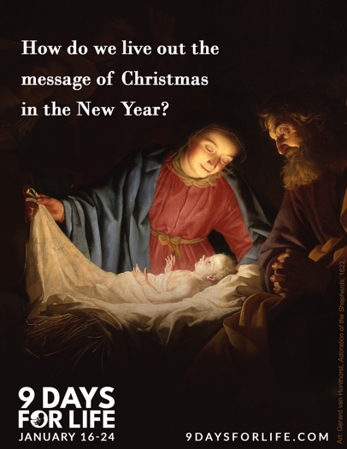
“Living Out Christmas in the New Year”
- Graphic & Reflection

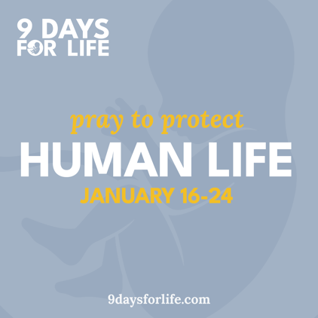
Sunday, January 7, 2024

- Promotional Graphics

Sunday, January 14, 2024
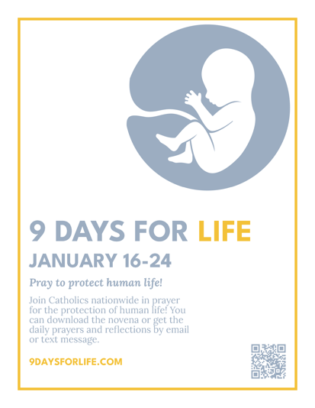
- Flyer (multiple dimensions)

