**Word of Life: October 2025**

*Recommended dates are provided, but you are welcome to use these materials at any time!*

[**Respect Life Month 2025**](https://www.respectlife.org/respect-life-month)**: *Life: Our Sign of Hope***

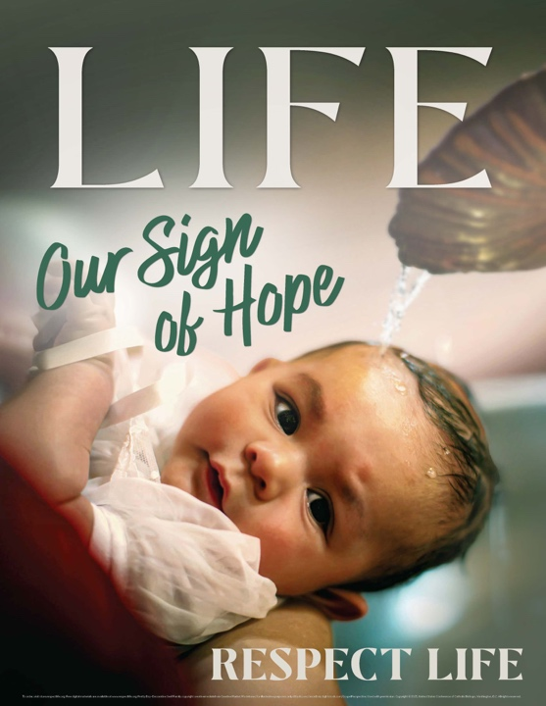The 2025 Respect Life Month resources have been developed to assist you in helping parishioners understand and value the gift of human life and become engaged with building a culture that cherishes every human life.

A variety of materials are [available to order in print](https://store.respectlife.org/collections/2025-respect-life-resources-life-our-sign-of-hope) or to download online.

Visit [respectlife.org/respect-life-month](http://www.respectlife.org/respect-life-month)!

**Resources**

* Poster ([Order](https://store.respectlife.org/collections/2025-respect-life-resources-life-our-sign-of-hope/products/2025-respect-life-poster))
* Prayer Card ([Order](https://store.respectlife.org/collections/2025-respect-life-resources-life-our-sign-of-hope/products/a-prayer-for-hope))
* Novena
* Respect Life Month Action Guide   
  *(a sample timeline, action ideas & more!)*
* Respect Life Reflection
* Graphics
* Homily Helps for Respect Life Sunday
* Pro-Life Articles

**Sample Pulpit Announcements**

**Option 1 (October 18-19)**

Join Catholics nationwide praying a Respect Life Month novena October 22nd through the 30th. See the bulletin for more information.

**Option 2 (any weekend in October)**

Every October, the Church in the U.S. celebrates Respect Life Month. We reflect on the gift of *every* human life and how to build a culture that protects life from conception to natural death. See the bulletin for more information.

**Sample Bulletin Announcements**

**Option 1 (October 18-19)**

Join thousands of Catholics praying a Respect Life Month novena Wednesday, October 22 – Thursday, October 30. Get daily prayers, reflections, and more. Sign up at **respectlife.org/celebrate**

**Option 2 (any weekend in October)**

**It’s Respect Life Month!**   
Join Catholics nationwide in celebrating Respect Life Month. Visit **respectlife.org/celebrate**

**Word of Life – October 2025**

**Intercessions for Life**

|  |  |
| --- | --- |
| **October 5th**  For all Catholics: that on this Respect Life Sunday, the Lord will strengthen our resolve  to protect the gift of every human life; *let us pray to the Lord:* | **Twenty-seventh Sunday**  **in Ordinary Time**  ***(Also observed in the U.S. as***  ***Respect Life Sunday)*** |
| **October 12th**  For those nearing the end of life: may they receive care that  respects their dignity as they prepare in hope  to share eternal life with Christ; *let us pray to the Lord:* | **Twenty-eighth Sunday**  **in Ordinary Time** |
| **October 19th**  For women and men suffering after  participating in an abortion: may the Church’s abortion healing ministry,  help them find peace and healing  through God’s endless mercy; *let us pray to the Lord:* | **Twenty-ninth Sunday**  **in Ordinary Time** |
| **October 26th**  May the Lord help us to understand more deeply  the challenges of pregnant and parenting moms  and to respond with increased care and support;  *We pray to the Lord:* | **Thirtieth Sunday**  **in Ordinary Time** |

**Word of Life – October 2025**

**Bulletin Quotes**

|  |  |
| --- | --- |
| **October 5th**  “We are called to be signs of hope to all people, especially those whose goodness, value, and dignity are undermined. As members of the Body of Christ, we carry this hope with us as we continue Jesus’ mission on earth… We have been entrusted with a message of hope for the woman who finds herself unexpectedly pregnant or for the man diagnosed with a terminal illness. At these challenging moments, we must bring God’s presence, witnessing to His love, and inspiring a renewal of hope in those whose hearts are burdened.”  USCCB Secretariat of Pro-Life Activities  Respect Life Reflection: “Life: Our Sign of Hope” | [Download](https://www.usccb.org/resources/respect-life-reflection-life-our-sign-hope) | [Read Online](https://www.respectlife.org/life-our-sign-of-hope) |
| **October 12th**  “An old Irish proverb says, ‘It is in the shelter of each other that the people live.’ Indeed, we are created to depend upon one another and walk together in suffering. But when family members or friends approach life’s end, we may not know how best to ‘shelter’ them. Here are some concrete ways we can compassionately care for them: [usccb.org/end-of-life-care](https://www.usccb.org/end-of-life-care).”  USCCB Secretariat of Pro-Life Activities  Caring for Loved Ones at Life’s End | [Download](https://www.usccb.org/resources/caring-loved-ones-lifes-end) | [Read Online](https://www.usccb.org/end-of-life-care) |
| **October 19th**  “I would now like to say a special word to women who have had an abortion. The Church is aware of the many factors which may have influenced your decision, and she does not doubt that in many cases it was a painful and even shattering decision. The wound in your heart may not yet have healed. …But do not give in to discouragement and do not lose hope. …The Father of mercies is ready to give you his forgiveness and his peace in the Sacrament of Reconciliation.”  Pope Saint John Paul II, *Evangelium vitae,* no. 99. © 1995, Libreria Editrice Vaticana.  Used with permission. All rights reserved. | A screenshot of a cell phone  Description automatically generated  [Read Online](http://w2.vatican.va/content/john-paul-ii/en/encyclicals/documents/hf_jp-ii_enc_25031995_evangelium-vitae.html) |
| **October 26th**  “The witness of our Blessed Mother [in the Gospel account of her visit to her pregnant cousin, Elizabeth,] invites us to become more aware of the needs of pregnant and parenting moms in our own parishes and communities. …Mary’s witness is an invitation to step out in love and compassion. It is a summons to *make haste* to help vulnerable women who may be isolated and alone.”  USCCB Secretariat of Pro-Life Activities  Respect Life Reflection: Called to Serve Moms in Need  respectlife.org/called-to-serve-reflection | [Download](https://www.usccb.org/resources/respect-life-reflection-called-serve-moms-need) | [Read Online](https://www.respectlife.org/called-to-serve-reflection) |

**Word of Life – October 2025**

**Bulletin Art**

*You are welcome to use these and other downloadable images from the* [***online Respect Life image gallery***](https://www.respectlife.org/respect-life-image-gallery)*, provided they are not altered in any way, other than the size. Thank you!*

**Sunday, October 5th, 2025**

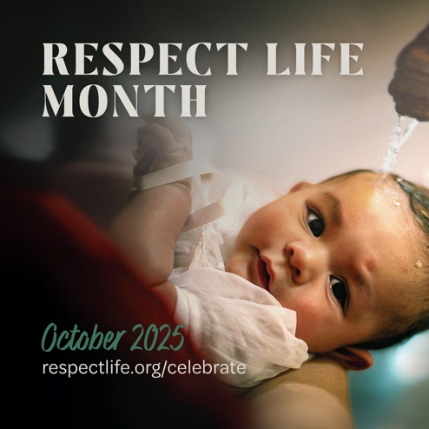

[Download image](https://www.usccb.org/resources/rlp-25-rlm-square.png) / [[Additional images](https://www.usccb.org/resources/2025-respect-life-month-graphics)](https://www.usccb.org/resources/2025-respect-life-month-graphics)

Corresponding announcement:

**It’s Respect Life Month!**   
Join Catholics nationwide in celebrating Respect Life Month. Visit **respectlife.org/celebrate.**

**Sunday, October 19th, 2025**

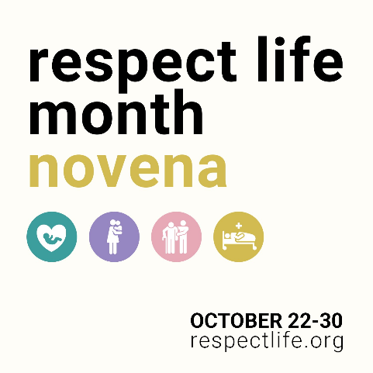

[Download image](https://www.usccb.org/resources/respect-life-graphics-respect-life-month-novena)

Corresponding announcement:

Join thousands of Catholics praying a Respect Life Month novena Wednesday, October 22 – Thursday, October 30. Get daily prayers, reflections, and more. Sign up at **respectlife.org**!

**Sunday, October 26th, 2025**

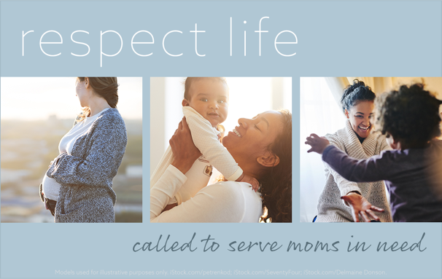[Download image](https://www.usccb.org/sites/default/files/2022-09/rlp-22-web-content-1090x690.png)

Corresponding quote:

The witness of our Blessed Mother [in the Gospel account of her visit to her pregnant cousin, Elizabeth,] invites us to become more aware of the needs of pregnant and parenting moms in our own parishes and communities. Read more at respectlife.org/called-to-serve-reflection.