Word of Life: December 2025
Recommended dates are provided, but you are welcome to use these materials at any time!
Featured this Month…
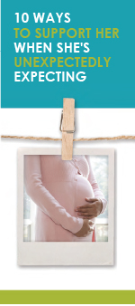
Advent
The season of Advent is a time of anticipation that directs our hearts and minds to preparing for the celebration of the Lord’s birth on Christmas and for Christ’s second coming at the end of time. During this time of preparation and expectant waiting, we also remember expectant mothers who are preparing for the birth of their children. This Advent season, consider highlighting the article “10 Ways to Support Her When She’s Unexpectedly Expecting.” (It is available in a variety of formats at the bottom of this webpage.)

Solemnity of the Immaculate Conception of the Blessed Virgin Mary
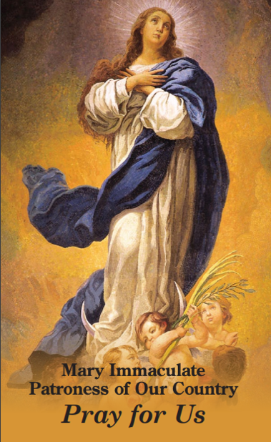
Patronal feast day of the United States of America (December 8th, 2025)
On December 8th, the Church celebrates the Solemnity of the Immaculate Conception of the Blessed Virgin Mary. (This feast is a holy day of obligation for dioceses in the United States.) On this feast, we celebrate Mary’s conception free from the stain of Original Sin, and we recognize that Mary’s life began the moment she was conceived in the womb of St. Anne. So, too, does every human life begin at the moment of fertilization: “You formed my inmost being; you knit me in my mother’s womb” (Ps 139:13).
On this solemnity, consider praying Pope Francis’ Prayer for the Immaculate Conception: “We are in need of your immaculate gaze, to rediscover the ability to look upon persons and things with respect and awareness.”

Word of Life – December 2025
Intercessions for Life
December 7th  For women who are unexpectedly pregnant:  May they be filled with trust in God’s providence  and lovingly welcome the gift of their child,  let us pray to the Lord. | Second Sunday of Advent
December 8th  May God help us prepare the way of the Lord  by acting with tenderness and compassion,  especially toward the most vulnerable among us,  let us pray to the Lord. | Solemnity of the Immaculate Conception of the Blessed Virgin Mary
December 14th  For all victims of human trafficking:  May they find hope and healing  in the Lord who proclaims liberty to captives  and release to prisoners,  let us pray to the Lord. | Third Sunday of Advent
December 21st  For all parents awaiting the birth of their child:  May they look to the Blessed Mother and Saint Joseph  and follow their example  of cherishing and protecting human life,  let us pray to the Lord.  December 25th  For all Christians:  May the birth of Our Lord Jesus Christ  awaken in our hearts wonder  at the precious gift of every child,  let us pray to the Lord.  December 28th  For all families:  As the domestic Church,  may they pursue holiness,  pass on the faith, and persevere in love,  let us pray to the Lord. | Fourth Sunday of Advent  The Nativity of the Lord (Christmas)  Feast of the Holy Family of Jesus, Mary and Joseph

Word of Life – December 2025

Bulletin Quotes
December 7th  “Perhaps one of your friends has become pregnant unexpectedly. As someone who has been there, I encourage you to support your friend in her new journey of being a mother.” Learn how at respectlife.org/support-her.  USCCB Secretariat of Pro-Life Activities  “10 Ways to Support Her When She’s Unexpectedly Expecting” | 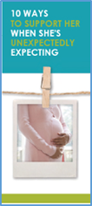  Download | Order
December 14th  “O St. Bakhita, assist all those who are trapped in a state of slavery;  Intercede with God on their behalf so that they will be released from their chains of captivity. Those whom man enslaves, let God set free.”  USCCB, “Prayer to St. Josephine Bakhita” | 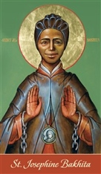  Download
December 21st  “O Blessed Mother, at the angel’s word you went in haste to the aid of your cousin Elizabeth. Although pregnant yourself, you placed her needs before your own. By your example of radical solidarity, teach us to reverence and protect those in need, without conditions or expectations… Obtain for us the grace to bring Christ to any expectant mother who is alone and afraid.”  USCCB Secretariat of Pro-Life Activities  Prayer for Radical Solidarity (www.respectlife.org/prayer-for-radical-solidarity) | 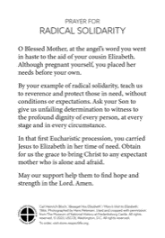  Download | Order
December 28th  “Dearest St Joseph… Help us to faithfully commit ourselves to the service and defense of human life —especially where it is vulnerable or threatened. Obtain for us the grace to do the will of God in all things.”  USCCB Secretariat of Pro-Life Activities  A Prayer to St. Joseph, Defender of Life (www.respectlife.org/prayer-to-st-joseph) | 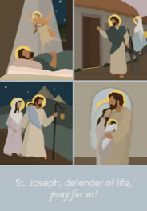  Download | Order

Word of Life - December 2025

Bulletin Art
You are welcome to use these and other downloadable images from the online Respect Life image gallery, provided they are not altered in any way, other than the size. Thank you!
Sunday, December 7th, 2025
Featuring “10 Ways to Support Her When She’s Unexpectedly Expecting”
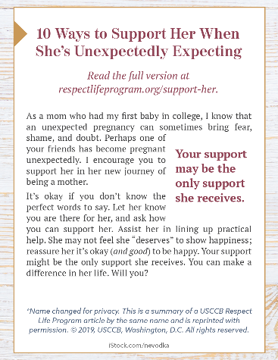
- Bulletin Box

Sunday, December 21st, 2025
Featuring “Radical Solidarity”
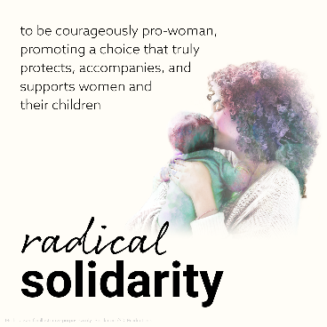
- Graphic
- Bulletin Insert

Sunday, December 28th, 2025
Featuring Living out Christmas in the New Year
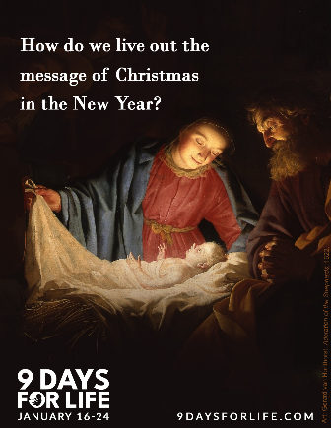
- Graphic
- Reflection

