Word of Life: January 2026
Recommended dates are provided, but you are welcome to use these materials at any time!
Featured this Month…
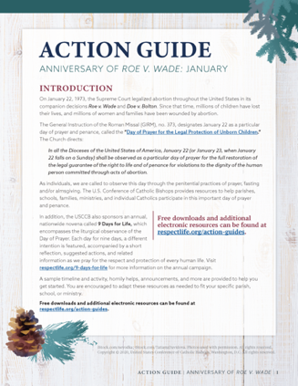
- Parish Action Guide: Anniversary of Roe v. Wade
Beginning on January 22, 1973 with Roe v. Wade, and during the nearly 50-year period following the Supreme Court decision, nearly 64 million children have been killed—and untold numbers of women and men suffer in the aftermath. Even with the overturning of Roe v. Wade in June 2022, many states continue not to recognize children in their mothers’ wombs as persons warranting protection, and federal laws fail to protect the lives of unborn children. The January Action Guide is available to help parishes, schools, and ministries highlight the sacredness of human life and pray for the protection of unborn children.
- Day of Prayer and Penance
(January 22, 2026)
January 22 is designated as a particular day of prayer and penance for Catholics in the United States, called the “Day of Prayer for the Legal Protection of Unborn Children.” The General Instruction of the Roman Missal (GIRM), no. 373, directs:
In all the Dioceses of the United States of America, January 22 (or January 23, when January 22 falls on a Sunday) shall be observed as a particular day of prayer for the full restoration of the legal guarantee of the right to life and of penance for violations to the dignity of the human person committed through acts of abortion.
Choices of Readings for Mass and other resources are available online in the January Action Guide.
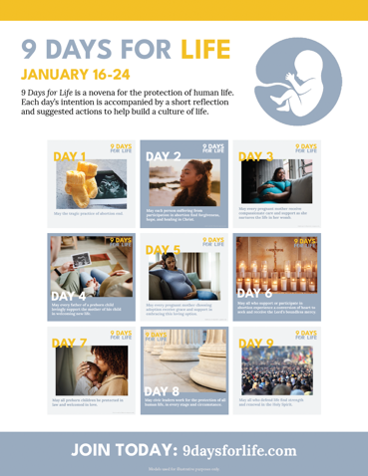
- 9 Days for Life
(January 16 – 24, 2026)
9 Days for Life is a novena for the protection of human life. Each day’s intention is accompanied by a short reflection and suggested actions to help build a culture of life. Participants can receive the novena by subscribing to daily emails or text messages. (A printable version is also available online.)
Leaders’ resources are available for download, including flyers, graphics, sample announcements, and the novena. Download or sign up for the novena at www.9daysforlife.com.

Word of Life – January 2026
Intercessions for Life
January 1st  May friends and families of women  with difficult pregnancies  provide loving, life-affirming support  for both mother and child,  let us pray to the Lord: | Solemnity of Mary, the Holy Mother of God
January 4th  On this Solemnity of the Epiphany,  may we be given the grace  to always see in others  the face of Christ our Savior,  let us pray to the Lord: | The Epiphany of the Lord
January 11th  For all Christians,  may we live out our baptismal call  to proclaim the Gospel of God’s love  and the dignity of every human life,  let us pray to the Lord: | The Baptism of the Lord
January 18th  For public servants and elected officials,  may God grant them the humility, wisdom,  and courage to defend all human life,  let us pray to the Lord: | Second Sunday in Ordinary Time
January 22nd  For the legal protection of unborn children  and for loving support for their mothers  before and after their births,  let us pray to the Lord: | Day of Prayer for the Legal Protection of Unborn Children
January 25th  For those suffering after abortion,  may they know that the Lord desires to bring healing,  and may they turn to Him for His mercy and peace,  let us pray to the Lord: | Third Sunday in Ordinary Time

Word of Life – January 2026
Bulletin Quotes
January 1st  “O Blessed Mother, you received the good news of the incarnation of Christ, your Son, with faith and trust. Grant your protection to all pregnant mothers facing difficulties. Guide us as we strive to make our parish communities places of welcome and assistance for mothers in need. Help us become instruments of God’s love and compassion.”  USCCB Secretariat of Pro-Life Activities  “A Prayer for Pregnant Mothers” | 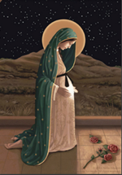  Order | Download  Online
January 4th  “Through the Incarnation and birth of Christ, God reveals to us the dignity of all human life. Human life, as a gift of God, is sacred and inviolable. The Son of God has united himself with every human being and desires for us to share eternal life with him… Each of us is made in the image and likeness of God, and we reflect his glory in the world.”  USCCB Secretariat of Pro-Life Activities  “The Gospel of Life: A Brief Summary” | 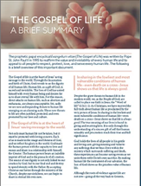  Download | Read Online  Online
January 11th  “Heavenly Father, in the sacrament of Baptism, you have given us the gift of new life. Through your son our Lord Jesus Christ and the Holy Spirit, you have made us your own. Help us to recognize the gift of human life as a sign of hope in our world. Reveal to us the places where your precious gift of life is most in need of protection and strengthen us to defend life in all stages and circumstances, from the child in the womb to the elderly and dying. Guided by your Holy Spirit, guard us from discouragement and give us the grace to be messengers of hope, filled with confidence that nothing can separate us from your love.”  USCCB Secretariat of Pro-Life Activities  “A Prayer for Hope” | 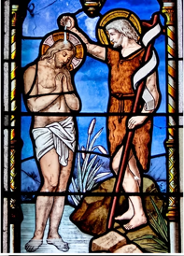  Order | Download
January 18th  “Even with the overturning of Roe v. Wade in June 2022, a decision that returns the abortion issue to the electorate, many states continue not to recognize children in their mothers’ wombs as persons warranting protection under the law. Federal laws in our country fail to protect the lives of unborn children, and many political leaders at the state and federal level, work actively to increase access to abortion. Some falsely describe it as health care and even as a basic human right.”  USCCB Secretariat of Pro-Life Activities  “Priorities at the Polls” | 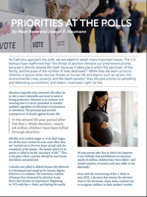  Download | Read Online
January 25th  Many people are unaware that someone they know personally is silently suffering from participation in abortion. If a friend confided in you tomorrow that she had an abortion, would you be able to respond in a way that brings her closer to healing? Learn how in “How to Talk to a Friend Who’s Had an Abortion”: http://bit.ly/friend-had-abortion  USCCB Secretariat of Pro-Life Activities  “How to Talk to a Friend Who’s Had an Abortion” |   Order | Read Online

Word of Life – January 2026

Bulletin Art
You are welcome to use these and other downloadable images from the online Respect Life image gallery, provided they are not altered in any way, other than the size. Thank you!
Sunday, January 4, 2026
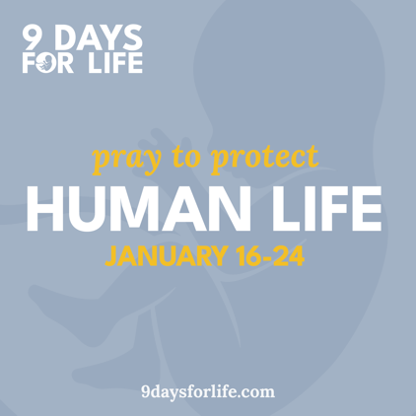

Promotional Graphics

Sunday, January 11, 2026
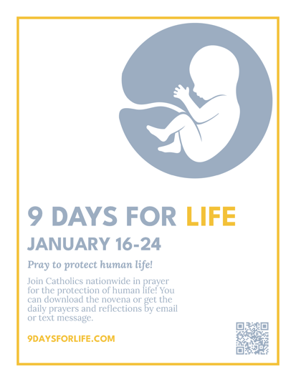
Flyer (multiple dimensions)

