Word of Life: March 2026
Recommended dates are provided, but you are welcome to use these materials at any time!
Featured this Month…
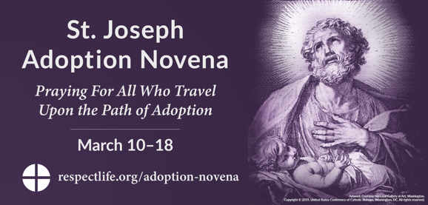
St. Joseph Adoption Novena: March 10-18, 2026
Leading up to the Solemnity of St. Joseph on March 19, join us in praying the St. Joseph Adoption Novena. Invoking the intercession of St. Joseph, foster father of Jesus, we will pray the Lord blesses all whose life stories include adoption. Additional resources are available.

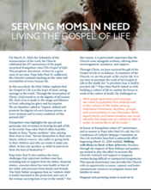
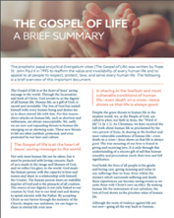
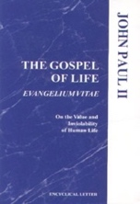
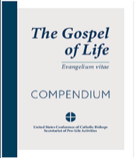
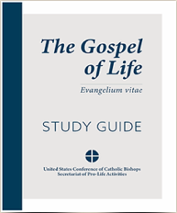
Anniversary of Evangelium vitae: March 25, 2026

March 25th marks the anniversary of the papal encyclical Evangelium vitae (The Gospel of Life). Several resources are available to help you observe this anniversary in your parish, including The Gospel of Life: Compendium and Study Guide. Additional resources including bulletin inserts and graphics are available at respectlife.org/gospel-of-life.

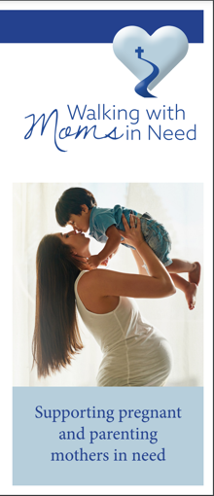
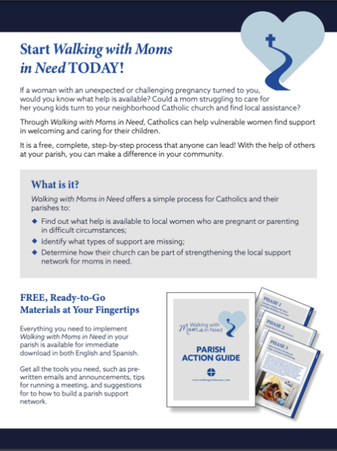
Walking with Moms in Need
Pregnant and parenting moms in need are in our parishes and our neighborhoods. Everyone in a parish community should know where to refer a pregnant woman in need. Walking with Moms in Need provides a process for parishes to assess, expand, and better communicate resources to pregnant moms and families in need. Learn more and get started today!
- Website
- Testimonials
- Webinars
- Parish Resources
- Promotional Flyer | Brochure
- Newsletters

Word of Life – March 2026
Intercessions for Life
March 1st  For each expectant mother considering abortion:  May the Lord provide for her needs  and give her the grace and resolve  to choose life for her child,  let us pray to the Lord: | Second Sunday of Lent
March 8th  For those nearing the end of life:  May they be given the grace to persevere in faith  and place their trust in God  as they prepare in hope for eternity with Christ,  let us pray to the Lord: | Third Sunday of Lent
March 15th  For married couples considering adoption,  may the Holy Spirit guide their discernment,  grant them peace, and bring to fruition His holy will,  let us pray to the Lord: | Fourth Sunday of Lent
March 22nd  May all mothers facing difficult pregnancies  be lovingly accompanied as they prepare  to encounter Christ anew  through the gift of their children,  let us pray to the Lord: | Fifth Sunday of Lent
March 29th  For all those receiving hospice care:  May the care they receive  respect and protect their lives,  let us pray to the Lord: | Palm Sunday of the Lord’s Passion

Word of Life – March 2026
Bulletin Quotes
In honor of the anniversary of Evangelium vitae, the bulletin quotes for this month all come from this historic document. Additional artwork is provided for each bulletin quote this month. Please include the following credit with each quote:
Pope Saint John Paul II, Evangelium vitae. © 1995 Libreria Editrice Vaticana. Used with permission.
March 1st  The Gospel of Life is “meant to be a precise and vigorous reaffirmation of the value of human life and its inviolability, and at the same time a pressing appeal addressed to each and every person, in the name of God: respect, protect, love and serve life, every human life! Only in this direction will you find justice, development, true freedom, peace and happiness!” (The Gospel of Life 5). | 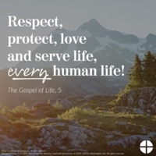  English | Spanish
March 8th  “We are facing an enormous and dramatic clash between good and evil, death and life, the ‘culture of death’ and the ‘culture of life’. We find ourselves not only ‘faced with’ but necessarily ‘in the midst of’ this conflict: we are all involved and we all share in it, with the inescapable responsibility of choosing to be unconditionally pro-life” (The Gospel of Life 28). | 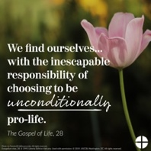  English | Spanish
March 15th  “To celebrate the Gospel of life means to celebrate the God of life, the God who gives life… In every child which is born and in every person who lives or dies we see the image of God’s glory. We celebrate this glory in every human being, a sign of the living God, an icon of Jesus Christ” (The Gospel of Life 84). | 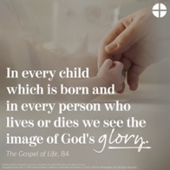  English | Spanish
March 22nd  “There is an everyday heroism, made up of gestures of sharing, big or small, which build up an authentic culture of life… Part of this daily heroism is also the silent but effective and eloquent witness of all those ‘brave mothers who devote themselves to their own family without reserve, who suffer in giving birth to their children and who are ready to make any effort, to face any sacrifice, in order to pass on to them the best of themselves’… We thank you, heroic mothers, for your invincible love! We thank you for your intrepid trust in God and in his love. We thank you for the sacrifice of your life” (The Gospel of Life 86). | 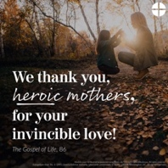  English | Spanish
March 29th  “With great openness and courage, we need to question how widespread is the culture of life today among individual Christians, families, groups and communities in our Dioceses. With equal clarity and determination we must identify the steps we are called to take in order to serve life in all its truth” (The Gospel of Life 95). | 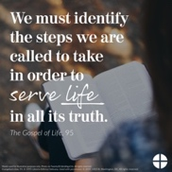  English | Spanish

Word of Life – March 2026

Bulletin Art
You are welcome to use these and other downloadable images from the online Respect Life image gallery, provided they are not altered in any way, other than the size. Thank you!
Sunday, March 1, 2026
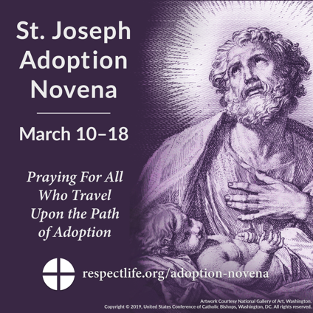
Download: English | Spanish

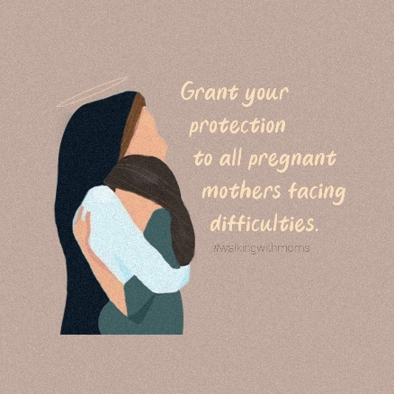
Sunday, March 22, 2026

Download
Additional Graphics: View and Download

Sunday, March 29, 2026
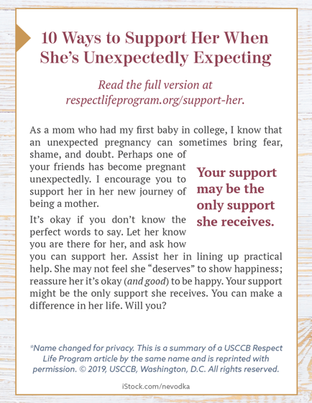
Bulletin Box: English | Spanish

