Word of Life: May 2026
Recommended dates are provided, but you are welcome to use these materials at any time!
Featured this Month…

May 10, 2026: Mother’s Day
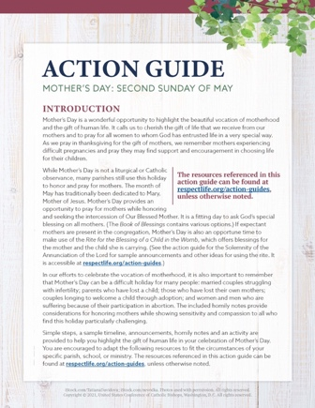
Mother’s Day is a wonderful opportunity to highlight the beautiful vocation of motherhood and the gift of life.
Our Mother’s Day action guide features homily considerations, intercessions, activity ideas that can be used in the parish or at home, and more, to assist with honoring and praying for mothers in your parish community.
A webinar recording of USCCB staff walking through the materials, as well as the presentation slides from that webinar, are available.
*You’re welcome to use one component of the action guide or the whole thing—whatever’s helpful!

Respect Life Reflection: St. Francis, Visionary of Life
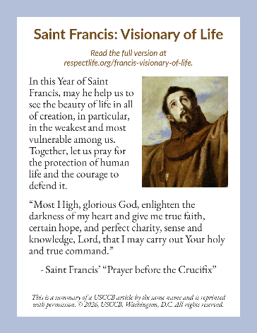
In honor of the 800th anniversary of Saint Francis of Assisi’s death, Pope Leo XVI has proclaimed a Jubilee Year of Saint Francis.
In this Year of Saint Francis, may he help us to see the beauty of life in all of creation, in particular, in the weakest and most vulnerable among us. Together, let us pray for the protection of human life and the courage to defend it.
Our downloadable resources feature a full reflection on Saint Francis and shorter "bulletin boxes". To find these resources and learn more about this Visionary of Life, click here!

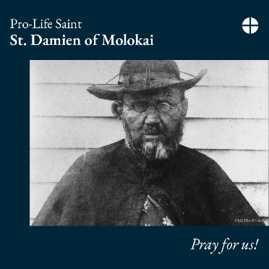
Saint of the Month
May 10, 2026: St. Damien of Molokai
St. Damien of Molokai was a Belgian priest who was sent to Hawaii to serve in a leper colony. He chose to stay in the colony and minister to the people's physical and spiritual needs even after he contracted leprosy himself. He saw profound dignity in every human life, especially the sick and dying, and dedicated his life to serve them.
St. Damien of Molokai, pray for us!

Word of Life – May 2026

Intercessions for Life
May 3rd  For those suffering after abortion:  May they know that the Lord desires to bring healing,  and turn to Him for His mercy and peace;  let us pray to the Lord: | Fifth Sunday of Easter
May 10th  May our parish community come together  to become a place of welcome and assistance  for all mothers in need;  let us pray to the Lord: | Sixth Sunday of Easter  (Mother’s Day is not a liturgical feast but is often recognized at Mass.)
May 17th  For all Christians:  May our example give witness to  the precious gift of human life and  our responsibility to protect it until its natural end;  let us pray to the Lord: | The Solemnity of the Ascension of the  Lord (or Seventh Sunday of Easter  where applicable)
May 24th  May the Holy Spirit strengthen God’s people  to embrace and protect  the precious gift of human life;  let us pray to the Lord: | Pentecost Sunday
May 31st  May we more deeply respect  the gift of each person,  who is created and called to holiness  by the gracious action of the Trinity;  let us pray to the Lord: | The Solemnity of the Most Holy Trinity

Word of Life – May 2026
Bulletin Quotes
May 3rd  “In this Year of Saint Francis, may he help us to see the beauty of life in all of creation, in particular, in the weakest and most vulnerable among us. Together, let us pray for the protection of human life and the courage to defend it.”  USCCB Secretariat of Pro-Life Activities, “Saint Francis: Visionary of Life” | 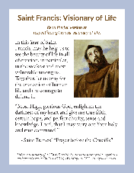  Read Online | Download
May 10th  “Radical solidarity compels us to come alongside vulnerable mothers in profound friendship, compassion, and support for both them and their preborn children. It requires us to address the fundamental challenges that lead an expectant mother to believe she is unable to welcome the child God has entrusted to her. We must do all we can to provide mothers, children, and families with the support they need to flourish. This cannot be accomplished by laws or policy alone, but requires the continual transformation of our own hearts, recognizing in every person the face of Christ, and placing their needs before our own.”  USCCB Secretariat of Pro-Life Activities, “Radical Solidarity” | 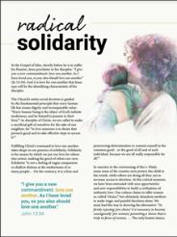  Read Online | Download
May 17th  “The Lord says to us, ‘Do not fear: I am with you’ (Isaiah 41:10). He speaks these words not as one who merely observes our pain, but as one who experienced immense suffering. And the very wounds that bear witness to his suffering indicate the essence of our identity and worth: we are loved by God. Reflecting on the healed wounds of the Risen Christ, we see that even our most difficult trials can be the place where God manifests his victory. He makes all things beautiful. He makes all things new.”  USCCB Secretariat of Pro-Life Activities, “Be Not Afraid”  NABRE © 2010 CCD. Used with permission. | 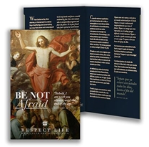  Order | Download
May 24th  “Even the weakest and most vulnerable, the sick, the old, the unborn and the poor, are masterpieces of God’s creation, made in his own image, destined to live forever, and deserving of the utmost reverence and respect.”  USCCB Respect Life flyer quoting Pope Francis’ “Day for Life Greeting”  © 2013 Libreria Editrice Vaticana. Used with permission. All rights reserved. | 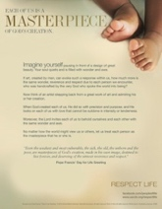  Order | Download
May 31st
“Dignity is a gift from God, who created the human being in his own image and semblance (cf. Gen 1:26). It is not something that is obtained by merit or effort; nor does it depend on what we possess or achieve. It is a gift that goes before us: it is born of the look of love with which God wanted us, one by one, and continues to want us."
Pope Leo XIV, Message to Participants in “Building Communities that Safeguard Dignity”
© 2025 Libreria Editricea Vaticana. Used with permission. All rights reserved.

Word of Life – May 2026

Bulletin Art
You are welcome to use these images, provided they are not altered in any way, other than the size. Thank you!

Sunday, May 10th, 2026
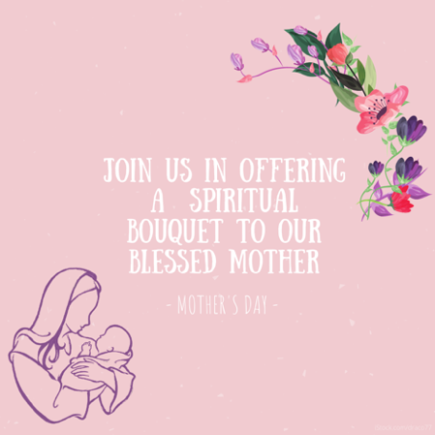
Download Image

Spiritual Bouqet Activity Instructions: Select “Activity (with at-home option)” from the list of documents on this page.

Sunday, May 24th, 2026
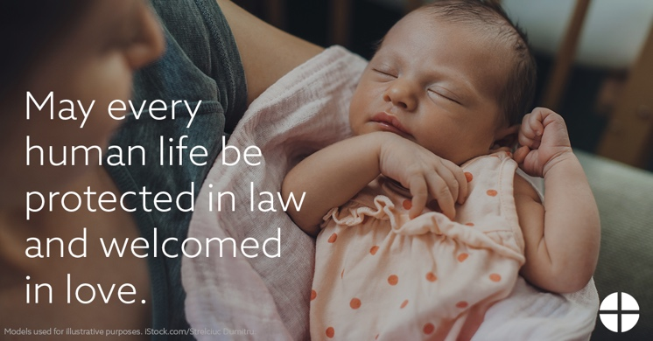
Download: English | Spanish

