Word of Life: June 2026
Recommended dates are provided, but you are welcome to use these materials at any time!
Featured this Month…
Consecrating the United States to the Sacred Heart of Jesus

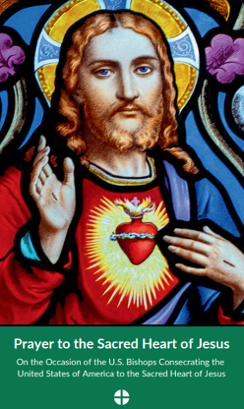
In June 2026, as part of the celebration of the 250th anniversary of the signing of the Declaration of Independence, the U.S. bishops will consecrate the United States of America to the Sacred Heart of Jesus. Parishes around the country are encouraged to join the bishops in consecrating our nation to the Sacred Heart in June.

For more information & resources, visit www.usccb.org/weholdthesetruths.
- 250 Hours of Adoration
- Holy Hour for Life
- Litany of the Sacred Heart of Jesus

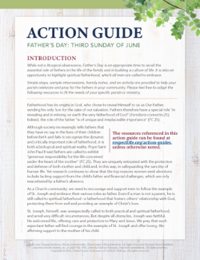
Father’s Day Action Guide: June 21, 2026
The Father’s Day Action Guide will help your parish honor fathers and highlight their importance in building a culture of life. The activity can be done together as a parish or at home.
- Webinar Recording
- Action Guide (English | Spanish)
- Supplemental Resources

Religious Freedom Week: June 22–29, 2026
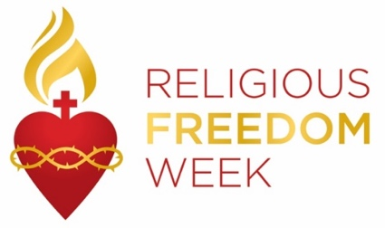
Religious Freedom Week 2025 takes place June 22–29. The Week begins with the Memorial of Ss. John Fisher and Thomas More, ends with the Solemnity of Ss. Peter and Paul, and includes the Solemnity of the Nativity of St. John the Baptist. Resources will be made available to help the faithful pray, reflect on, and take action for religious liberty, both here in this country and abroad. They will be made available at usccb.org/ReligiousFreedomWeek.
Saint of the Month
June 24, 2026: Nativity of St. John the Baptist

In 2022, on the feast of the Nativity of St. John the Baptist, the Supreme Court case Roe v Wade, which legalized abortion nationwide, was overturned. St. John the Baptist was the first person to recognize Jesus in the womb of the Blessed Mother. While still in the womb himself, he leapt for joy at the presence of Christ. May we too rejoice in the gift of every preborn child and pray for their legal protection.
St. John the Baptist, pray for us!
Word of Life – June 2026
Intercessions for Life
June 7th  May the worthy reception of Jesus in the Eucharist  strengthen our commitment  to protect the gift of human life  from conception to natural death;  let us pray to the Lord: | The Solemnity of the Most Holy Body and Blood of Christ (Corpus Christi)
June 14th  For our nation:  May we build a society  in which the legal protection of human life  is accompanied by profound care  for mothers and their children;  let us pray to the Lord: | Eleventh Sunday in Ordinary Time
June 21st  May expectant fathers lovingly support  the mothers of their children  in welcoming new life;  let us pray to the Lord: | Twelfth Sunday in Ordinary Time (Father’s Day is not a liturgical feast but  is often recognized at Mass.)
June 28th  For religious liberty:  That all may have the freedom  to follow God’s commands  and protect his gift of human life;  let us pray to the Lord: | Thirteenth Sunday in Ordinary Time

Word of Life – June 2026

Bulletin Quotes

June 7th  “Christ’s blood reveals to man that his greatness, and therefore his vocation, consists in the sincere gift of self. …It is from the blood of Christ that all draw the strength to commit themselves to promoting life. It is precisely this blood that is the most powerful source of hope, indeed it is the foundation of the absolute certitude that in God’s plan life will be victorious.”  Pope Saint John Paul II, Evangelium vitae © 1995, Libreria Editrice Vaticana. | 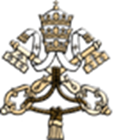  Read Online
June 14th  "As we reflect with gratitude on the blessings God has bestowed on our country, our devotion to the Sacred Heart demands that we consider how we might foster truth, justice, and charity in American life. We are called to bring our faith into the actions we take and the lives we lead in our communities. We celebrate the ways the Church has contributed to a more just world, and we invite all in our society to see the face of Christ reflected in each sister and brother."  Most Reverend Alexander K. Sample, Archbishop of Portland “Reflection on the Consecration to the Sacred Heart” | 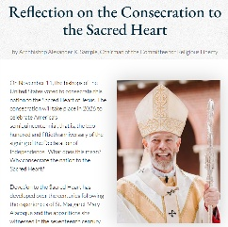  Read Online
June 21st  “Through our prayers and through the intercession of St. Joseph, patron of fathers, may fathers come to know the irreplaceable role they hold in the lives of their children, and the responsibility they share in welcoming God’s gift of new life!”  Most Reverend Shelton J. Fabre, Bishop of Houma-Thibodaux  “Fathers’ Irreplaceable Role in Welcoming Life” | 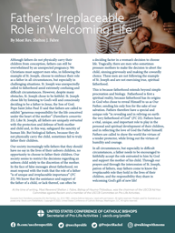  Read Online | Download
June 28th  “O God our Creator… we ask you to bless us in our vigilance for the gift of religious liberty. Give us the strength of mind and heart to readily defend our freedoms when they are threatened; give us courage in making our voices heard on behalf of the rights of your Church and the freedom of conscience of all people of faith.”  USCCB, “Prayer for the Protection of Religious Liberty” | 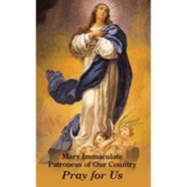  Read Online

Word of Life – June 2026

Bulletin & Social Media Art
You are welcome to use these, provided they are not altered in any way, other than the size. Thank you!

Sunday, June 7, 2026
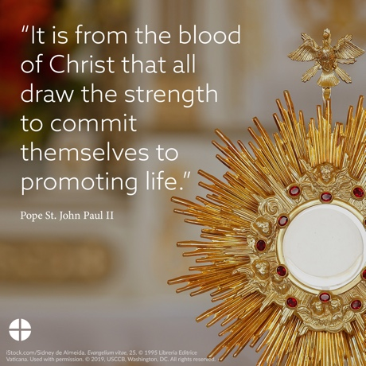
Download Image: English | Spanish

Sunday, June 14, 2026
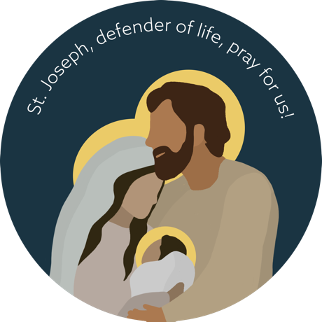
Download Image (Other graphics are available on the same webpages.): English | Spanish

Download Prayer Card

Sunday, June 21, 2026
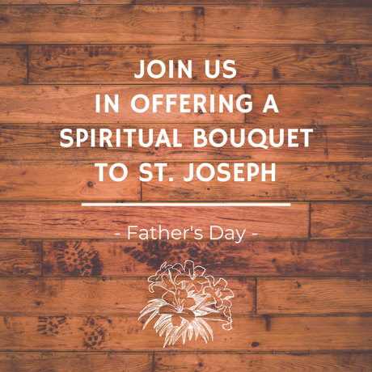
Download Image (Other graphics are available on the same webpages.): English | Spanish

