­­–­

**Act** *(choose one)*

* The Solemnity of the Presentation of the Lord is also known as Candlemas Day. Covid-19 restrictions may have prevented many parishes from distributing blessed candles, which would traditionally be used in Christian homes throughout the year as a symbol of Christ, the light of the world. You can still light your own candle in your home and pray this [Prayer for Candlemas Day](https://www.catholicculture.org/culture/liturgicalyear/prayers/view.cfm?id=1403), which the Church celebrated this month.
* Choose one day this week to give up your favorite form of entertainment. For example, you could choose to sacrifice television/movies, video games, or social media.
* Offer some other sacrifice or prayer that you feel called to do for this month’s intention.

**One Step Further**

The season of Lent begins on Ash Wednesday, February 17. Take time to prayerfully consider how you can incorporate support for mothers in need into your Lenten commitments during this penitential season through prayer, service, penance, and/or almsgiving.

**Intercede**

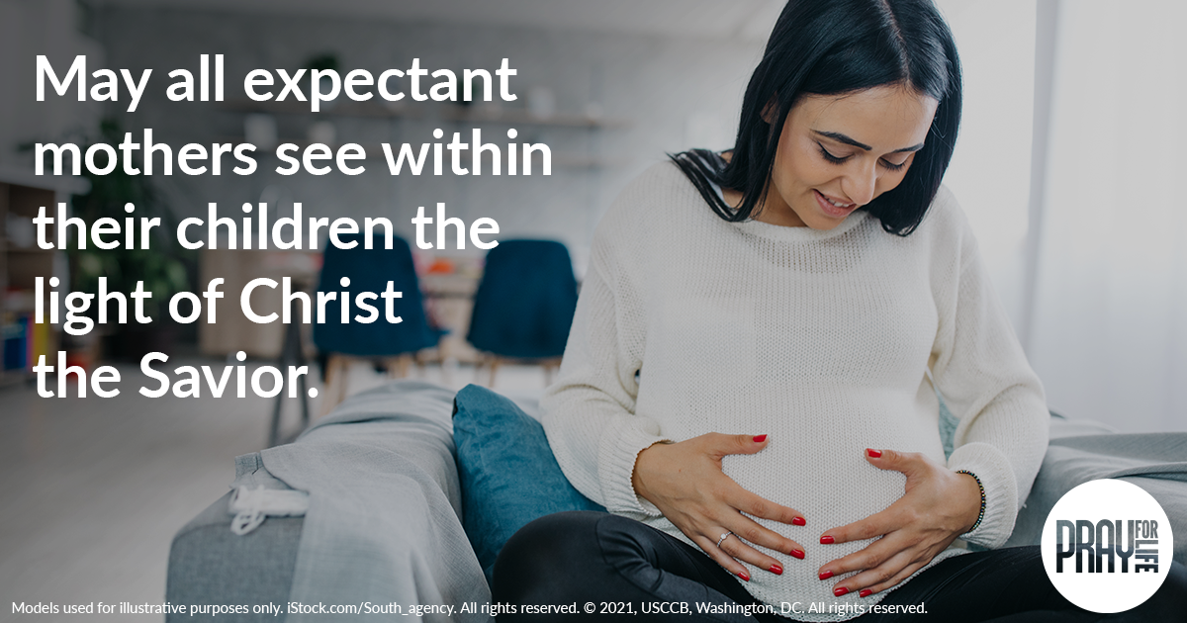

**Pray**

*Our Father, 3 Hail Marys, Glory Be*

**Reflect**

This month, the Church celebrated the Solemnity of the Presentation of the Lord, commemorating the visit of the Holy Family to the Temple to present the infant Jesus to the Lord, according to Jewish law. The feast of the Presentation recalls that Jesus came to be “a light for revelation” (*Luke* 2:32), as Simeon declared while prophesying the Christ Child’s mission of salvation. Simeon also prophesied of the Blessed Mother’s role in this redemptive mission, which would include her own crosses.

Each of us is also called to participate in Christ’s mission of salvation, to bear his light in the world and to see his face in every person. Through the gift of human life, we are invited to encounter God in a profound way. Mothers fulfill this call in a special way, nurturing the lives of their children within themselves. The Blessed Mother’s witness of sacrifice, faithfulness, and humility is an example for us all, and in a special way, for mothers entrusted with God’s gift of new life. Like Mary, may all expectant mothers see within their own children the light of Christ our Savior.

*Image: A mosaic of Our Lady of Guadalupe decorates a side altar in the Church of Santa Maria della Famiglia at the Vatican. Dec. 15. (CNS photo/Paul Haring.)*