­­–­

**Act** *(choose one)*

* Pope Francis declared December 8, 2020 – December 8, 2021 as the Year of St. Joseph. Offer [a prayer to St. Joseph](https://www.usccb.org/saint-joseph#tab--prayer-) for all mothers in need.
* Listen to this [podcast episode](https://www.usccb.org/saint-joseph#tab--resources) unpacking the importance of this Year of St. Joseph. To go deeper, consider taking time to prayerfully read Pope Francis’ Apostolic Letter [*Patris corde*](http://www.vatican.va/content/francesco/en/apost_letters/documents/papa-francesco-lettera-ap_20201208_patris-corde.html) (*With a Father’s Heart*).
* Offer some other sacrifice or prayer that you feel called to do for this month’s intention.

**One Step Further**

On March 25th the Church celebrates the Solemnity of the Annunciation of the Lord, as well as the anniversary of the papal encyclical *Evangelium vitae* (*The Gospel of Life*). Learn more about how these two observances are connected in this [brief article](https://www.respectlife.org/he-made-his-dwelling-among-us).

**Did You Know?**

The Church also celebrates the Solemnity of Saint Joseph on March 19th. Join others in seeking the intercession of St. Joseph for the many people whose lives are touched by adoption by praying the novena from March 10th –18th. Sign up for daily email or text messages at [respectlife.org/adoption-novena](http://www.respectlife.org/adoption-novena).

**Intercede**

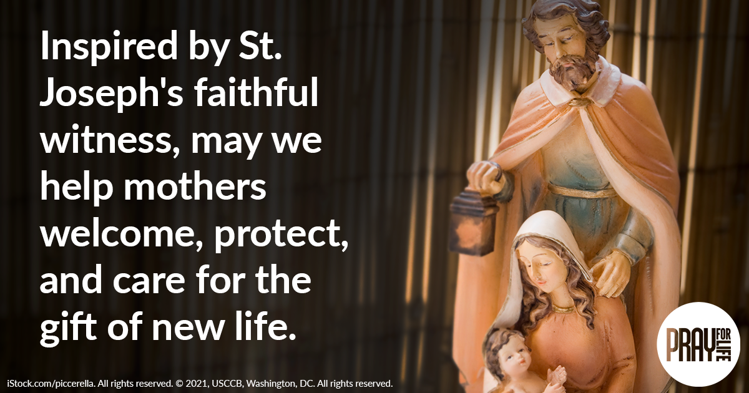

**Pray**

*Our Father, 3 Hail Marys, Glory Be*

**Reflect**

As Catholics we rightly find inspiration in Mary’s beautiful “fiat”, her “yes” to God’s will at the Annunciation, but we should also recall Joseph’s own faithful “yes” to God’s plan for salvation. Despite the unusual circumstances of Mary’s pregnancy, “Joseph accepted Mary unconditionally” (*Patris corde*, 4). Through a series of dreams, God made his will known to Joseph, and each time Joseph faithfully responded. It is Joseph who welcomed the Christ child as his own son, gave Jesus his name as revealed by the angel, and continually protected and provided for the needs of the Holy Family. When Herod threatened the life of the infant Jesus, Joseph fled with his family from their homeland to Egypt and patiently waited until they could return to Israel. “In every situation, Joseph declared his own ‘fiat’” (*PC*, 3). Through his constant care for both mother and child, Joseph makes a true gift of himself. God chose this humble carpenter of Nazareth to guide the beginnings of our redemption, and it is Joseph “who was able to turn a problem into a possibility by trusting always in divine providence” (*PC*, 5). Inspired by St. Joseph, may we proactively help mothers welcome and care for the gift of new life.

*Image: A mosaic of Our Lady of Guadalupe decorates a side altar in the Church of Santa Maria della Famiglia at the Vatican. Dec. 15. (CNS photo/Paul Haring.)*