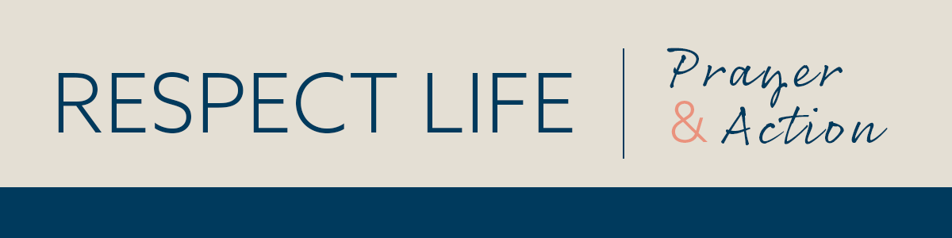

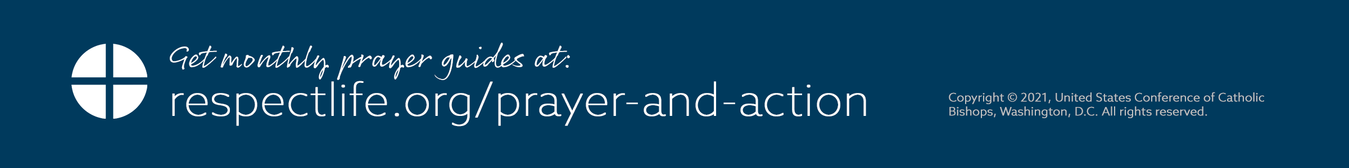­­

*Prayer Guide* | *MAY 2021*

–­

INTERCEDE

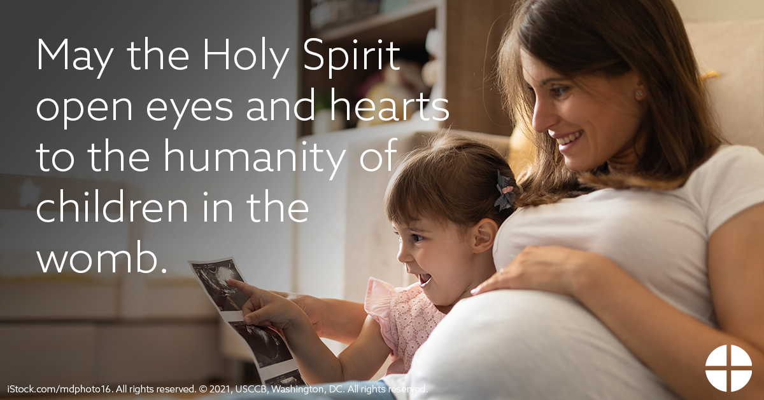

PRAY

*Our Father, 3 Hail Marys, Glory Be*

REFLECT

This month the Church celebrates the meeting of Mary and Elizabeth—and the infants in their wombs—in the Feast of the Visitation. The Gospel tells us that not only is Elizabeth overcome with joy at Mary’s greeting, but the unborn John the Baptist actually *leaps for joy* within her womb. Filled with the Holy Spirit, Elizabeth immediately recognizes the presence of the Lord concealed within his mother, as she cries out with the familiar words, “Most blessed are you among women, and blessed is the fruit of your womb” (*Lk* 1:42). It is the same presence that leads the unborn John to leap for joy.

This miraculous encounter beckons us to recognize the undeniable humanity of the infants hidden within the wombs of Mary and Elizabeth. Scripture also tells us that, following the Annunciation, Mary set out for the hill country in haste to visit Elizabeth, who is already six months pregnant. At the time of Mary’s arrival, she would have been in the earliest

stages of her pregnancy, yet Christ was already fully present and incarnate. Both Mary and Elizabeth place their trust in the Lord, and in doing so, bear life into the world. As we also celebrate the descent of the Holy Spirit at Pentecost this month, we pray that hearts will be opened to recognize the humanity of children in the womb. We also pray in thanksgiving for all mothers who give their own “yes” to God’s gift of human life.

ACT *(choose one)*

* In preparation for the Feast of the Visitation, join Catholics nationwide in praying A Novena for Life from May 22-30. (Sign up to receive the daily prayers at [respectlife.org/visitation](https://www.respectlife.org/visitation).)
* Read and meditate on the Gospel account of the Visitation ([Lk 1:39-56](https://bible.usccb.org/bible/readings/053121.cfm)). Ask the Lord how you can help witness to the humanity of children in the womb.
* Offer some other sacrifice or prayer that you feel called to do for this month’s intention.

ONE STEP FURTHER

Invite friends and family to join in praying the novena in honor of the Visitation by sharing this signup link: [respectlife.org/visitation](https://www.respectlife.org/visitation).

DID YOU KNOW?

The Church offers a “Rite of Blessing for Children in the Womb” ([usccb.org/blessing-in-the-womb](https://www.usccb.org/blessing-in-the-womb)) to support parents and to foster respect for human life. Expectant parents can seek this blessing from a priest or deacon.